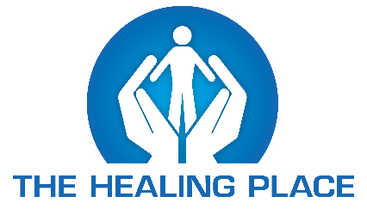

**2020 PREA Report:**

The Healing Place programs operate at a standard which meets or exceeds PREA guidelines, in accordance with regulations set by the Kentucky Department of Corrections (KDOC). ***The Healing Place has a zero-tolerance policy for a form of sexual harassment, abuse, or assault.*** PREA training is conducted for all staff, contractors, volunteers, and residents of The Healing Place programs that partner with the KDOC. Training includes definitions and examples of prohibited behaviors, as well as education about a preventative culture and healthy boundaries. Staff and residents are advised of multiple ways to report any allegations of sexual harassment, abuse, or assault. The Healing Place is committed to protecting residents from all forms of sexual abuse. Ongoing training will be provided to staff, contractors, volunteers, and residents to keep awareness of PREA standards at a high level.

In 2020, The Women’s Healing Place had 2 PREA related allegations with the following results: 1 unsubstantiated incident of staff sexual contact, 1 unsubstantiated incident of consensual resident sexual contact

In 2020, The Men’s Healing Place had 1 PREA related allegations with the following results: 1 unsubstantiated incident of resident sexual contact

In 2020, The Campbellsville Healing Place had 1 PREA related allegations with the following results: 1 unsubstantiated incident of resident sexual harassment

In 2020, The Brady Center had 0 PREA related allegations with the following results:

The Healing Place encourages residents, family members, friends, concerned citizens, contractors, volunteers, or staff to report any suspicion of sexual harassment, abuse, or assault by calling: The Healing Place at 502-585-4848, The Brady Center at 502-357-1971, The Kentucky Department of Corrections at 502-564-7023, Kentucky Probation and Parole at 502-896-1775, or by calling the PREA Hotline 833-362-7732.

Maurice Ludwick

The Healing Place

PREA Coordinator